All Overlays in random mode:
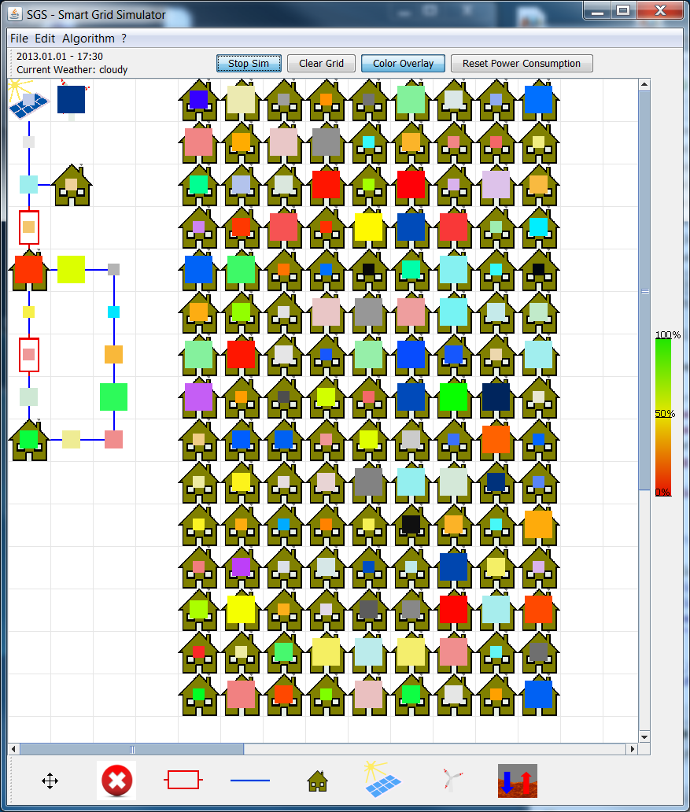

Black to white:
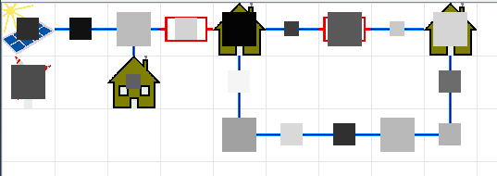
Green to red:
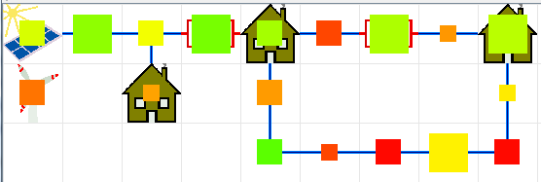

Blue to black:
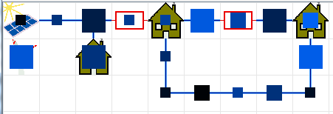

Other Overlays:
Single colors: From slight gray to color.
Red to Green to Blue.

